**Karan Arora** **R.L. Institute M: 9416974837**

**Max Time : 1 hr** **Class = 12th Chemistry Test**  **Max Marks : 25**

**Co-ordination compounds**

1. Multiple choice questions : [ 1 X 10 = 10]
2. NO2 is a :

|  |  |  |  |
| --- | --- | --- | --- |
| a) Monodentate ligand | b) Tetradentate ligand | c) Hexadentate ligand | d) Ambidentate ligand |

1. 2,4-dinitro phenyl hydrazine is an example of :

|  |  |  |  |
| --- | --- | --- | --- |
| a) Tridentate ligand | b) Monodentate ligand | c) Polydentate ligand | d) Didentate ligand |

1. Valence bond theory of co-ordination compounds was given by :

|  |  |  |  |
| --- | --- | --- | --- |
| a) Werner | b) Pauling | c) John Rowling | d) Van leck and Bethe |

1. Predict the number of ions produced per formula unit in an aqueous solution of [Co(en)3]Cl3.

|  |  |  |  |
| --- | --- | --- | --- |
| a) 4 | b) 3 | c) 6 | d) 2 |

1. The most stable complex is :

|  |  |  |  |
| --- | --- | --- | --- |
| a) [Fe(H2O)6]3 + | b) [Fe(NH3)6]3 + | c) [Fe(C2O4)3]3 + | d) [FeCl6]3 – |

1. Amongst the following ions, which has the highest paramagnetism?

|  |  |  |  |
| --- | --- | --- | --- |
| a) [Cr(H2O)6]3 + | b) [Fe(H2O)6]2 + | c) [Cu(H2O)6]2 + | d) [Zn(H2O)6]2 + |

1. The magnetic moment (spin only) of [NiCl4]2 – is :

|  |  |  |  |
| --- | --- | --- | --- |
| a) 1.82 B. M. | b) 5.46 B. M. | c) 2.82 B. M. | d) 1.41 B. M. |

1. Which of the following complex compound will exhibit highest magnetic behaviour?

|  |  |  |  |
| --- | --- | --- | --- |
| a) [Zn(NH3)6]2 + | b) [Ti(NH3)6]3 + | c) [Cr(NH3)6]3 + | d) [Co(NH3)6]3 + |

1. When one mole of CoCl3.5 NH3 was treated with excess of silver nitrate solution, 2 mole of AgCl was precipitated. The formula of the compound is :

|  |  |
| --- | --- |
| a) [Co(NH3)5 Cl2] Cl | b) [Co(NH3)5 Cl] Cl2 |
| c) [Co(NH3)4 Cl2] (NH3) Cl | d) [Co(NH3)3 Cl3] (NH3)2 |

1. Which of the following is an outer orbital complex and exhibit paramagnetic behaviour?

|  |  |  |  |
| --- | --- | --- | --- |
| a) [Ni(NH3)6]2 + | b) [Zn(NH3)6]2 + | c) [Cr(NH3)6]3 + | d) [Co(NH3)6]3 + |

1. Write the electronic configuration of Fe (III) on the basis of crystal field theory when it forms an octahedral complex in the presence of (i) Strong field ligand (ii) Weak field ligands. [ 1 ]
2. Using crystal field theory, draw energy level diagram, write electronic configuration of the central metal atom/ion and determine the magnetic moment value in the [Fe(H2O)6]2 + . [ 2 ]
3. Write IUPAC name of the following co-ordination compounds: [ 3 ]

|  |  |  |
| --- | --- | --- |
| 1. [Co(NH3)5 Cl] Cl2 | 1. K2 [PdCl4] | 1. [Pt (NH3)2 Cl (NH2 CH3)] Cl |

1. Explain on the basis of valence bond theory that [Ni (CN)4]2 – ion with square planer structure is diamagnetic and the [NiCl4]2 – ion with tetrahedral geometry is paramagnetic. [ 3 ]
2. What is meant by unidentate , bidentate and ambidentate ligands? Give two examples of each. [ 3 ]
3. Using IUPAC norms, write the formulae of the following : [ 3 ]

|  |  |
| --- | --- |
| a) potassium tetracyanidonickelate (II) | b) pentaamminenitrito-O-cobalt (III) |
| c) hexaamminecobalt (III) sulphate |  |

**Answers**

1. .

|  |  |  |  |  |  |  |  |  |  |
| --- | --- | --- | --- | --- | --- | --- | --- | --- | --- |
| 1. d | 1. b | 1. b | 1. a | 1. c | 1. b | 1. c | 1. c | 1. b | 1. a |

1. (i) (ii)
2. [Fe(H2O)6]2 + is a weak filled ligand ; therefore pairing not occur and configuration is = $t_{2g}^{4}$ $e_{g}^{2}$
3. (a) pentaamminechlorido cobalt (III) chloride (b) potassium tetrachloridopalladate (II)

(c) diamminechlorido (methylamine) platinum (ii) chloride

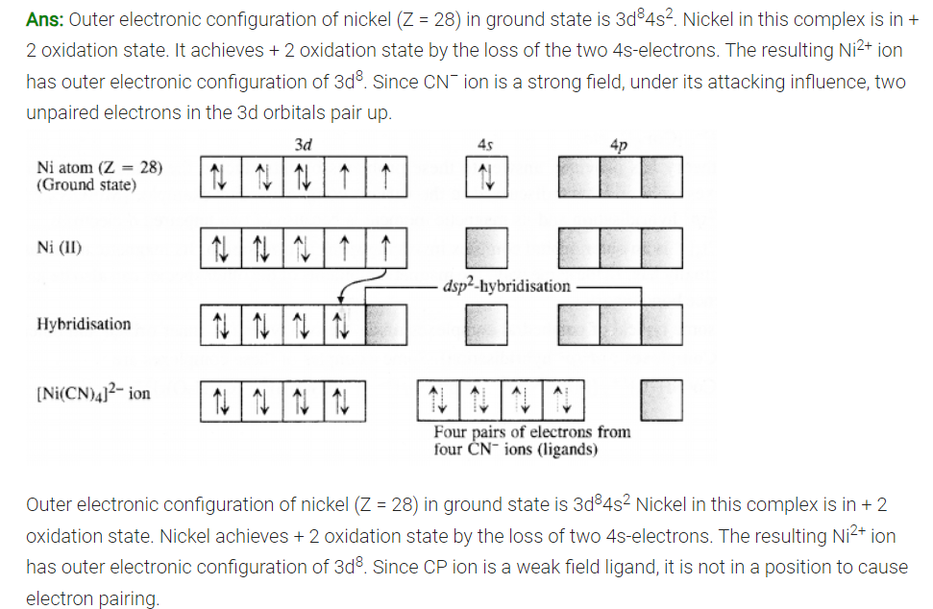

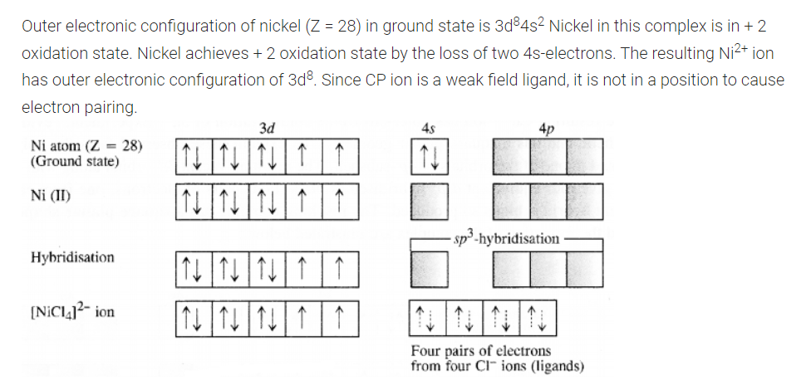

1. (i) Ligands having one donating group are known as unidentate ligands. E.g. CN – , etc.

(ii) Ligands having two donating group are known as bidentate ligands. E.g. oxalate ion (C2O4), etc.

(iii) Ligands having two donating group but donating through one group are known as ambidentate ligands. E.g. SCN –, etc.

|  |  |  |
| --- | --- | --- |
| 1. K2 [Ni (CN)4] |  | 1. [Pt (NH3)2 Cl (NH2 CH3)] Cl |